Economic Development Director
$64,680 - $84,456
Plus Excellent Benefits

Apply by
5:00 July 9, 2021
(First Review, Open Until Filled)
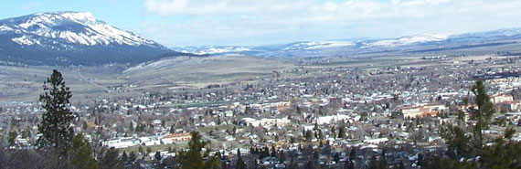

The City of La Grande, Oregon is located at the edge of the Grande Ronde Valley, east of the Blue Mountains. It is the county seat of Union County and home to Eastern Oregon University. A 250 mile stretch of I-84 connects La Grande with Portland and Western Oregon. To the east (175 miles) is Boise, Idaho. Boasting low crime rates and plenty of activities for kids, La Grande is a great family friendly city of just over 13,000 residents. In addition to Eastern Oregon University (EOU), the city has a public school system that includes one high school, a middle school and three elementary schools. The Cook Memorial Library is a modern facility in the heart of downtown that provides a wide array of programming for all ages. The City has 263 acres of parkland that include camping and fishing at Morgan Lake Park, highly groomed ballfields, several neighborhood parks, and a year-round indoor pool. La Grande is an ideal location for the outdoor enthusiast with beautiful rivers, valleys and mountains that afford everyone opportunities to enjoy one of the most scenic areas of Oregon. The Blue Mountains boast hiking, mountain biking, hunting, fishing and many other outdoor sports. You'll love exploring the areas surrounding La Grande.

The Department and Position
The Economic Development Director is a one-person department with shared administrative support. The ideal candidate will have a Bachelor’s degree in marketing, public or business administration, economic development, urban planning, or related field. A Masters Degree is preferred. Position requires a minimum of three years of responsible experience at a level which required the administration or management of projects and programs in economic development, entrepreneurial support, economics, business assistance, public facility or infrastructure development, commercial development, public and/or private finance, or workforce development. Experience in Urban Renewal is also preferred.

The Focus Areas of this position include:
- Implementation of the Goals within the City’s Urban Renewal Plan and related Urban Renewal Grant programs.
- Assisting in the recovery of the economy following the pandemic by supporting existing businesses.
- Managing the Ignite Center for Entrepreneurship in collaboration with Northeast Oregon Economic Development District.
- Working closely with La Grande Main Street Downtown (LGMSD), participating on the LGMSD Board of Directors and Chairing the LGMSD Economic Vitality Committee.
- Responding to recruitment opportunities.
- Preparing the City to transition into Resiliency and a pro-active recruitment strategy in the future.

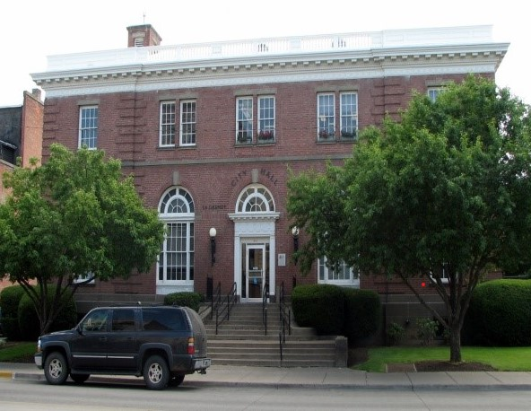
A successful candidate will:
- Possess knowledge of the principles and practices of: public administration; research methods and report presentation; municipal and private sector budgeting, accounting and finance methods; real estate purchase, sales and financing; urban land development; project development, scheduling, monitoring and control systems; economic principles and techniques; contract negotiations. Current knowledge of relevant developments in the field of economic development, Urban Renewal, Business Retention and Expansion (BR&E), and business recruitment.
- Demonstrate an ability to develop collaborative relationships with a broad-base of stakeholder groups including other city departments, the Urban Renewal Agency/City Council, La Grande Main Street Downtown, Northeast Oregon Economic Development Organization, EOU College of Business, Union County Chamber of Commerce, Business Oregon, the Small Business Development Center and private businesses and developers.
- Have a track record of success in achieving organizational outcomes along with strong analytical skills and the ability to resolve problems from a practical standpoint.
- Possess the ability to implement goals and objectives stated in the City of La Grande Urban Renewal Plan.
- Have successfully written and administered grants.
- Enjoy working with entrepreneurs and small businesses.

- Draft and administer a variety of plans and policies.
- Possess the ability to present difficult concepts in writing and through oral presentation.
- Manage and oversee the Economic Development Department Budget.

A proven ability to operate within a strong ethical framework and striving to uphold public trust are vital to success in the position.

Compensation and Benefits
Salary range: $64,680 - $84,456
The City of La Grande offers a comprehensive benefits plan that includes health, dental, and vision insurance.
Performance Increases – 4% step increase on anniversary date.
Retirement – Employer contribution 16% of salary.
Vacation – 12 to 25 days per year based on years of service.
Executive Leave – 80 hours per year.
Holidays – 12 paid holidays including two floating holidays.
Sick Leave – 12 days annually.
HRA/VEBA - $500 - $1500 employer contribution toward a health reimbursement account.
Additional Benefits – The City offers paid life insurance, long-term disability insurance, an air and ground ambulance membership. Employees can also participate in flexible spending accounts, alternate insurance for Accident, Cancer, additional life insurance, and much more.

Qualified candidates apply by July 9, 2021, to be considered during the first review, the position is open until filled. Submit a Cover Letter, Resume, and a completed City of La Grande Job Application to:

City of La Grande
Human Resource Department
Attention: Anita Zink
1000 Adams Avenue
La Grande, Oregon, 97850
Phone: 541-962-1319 Fax: 541-624-5817
azink@cityoflagrande.org

An application packet can be obtained on the City of La Grande website at www.cityoflagrande.org or by contacting Anita Zink.
La Grande is an Equal Opportunity Employer

